Comparing Respiration
Multiple Choice
- Define the operculum.
- A protective cover over the gills.
- Holds the gill filaments.
- The site of gas exchange.
- A respiratory organ.

- Define gill filaments.
- The site of gas exchange.
- Holds the gill filaments.
- A protective covering over the gills.
- A respiratory organ.

- Define a gill.
- The tail of aquatic animals.
- A protective cover over the gills.
- Respiratory organ of land animals.
- The respiratory organ of aquatic animals.

- Define the gills arch.
- The site of gas exchange.
- The respiratory organ of aquatic animals.
- The protective covering over the gills.
- Holds the gill filaments.

- Identify the name of the structure indicated by the red line in the picture below.
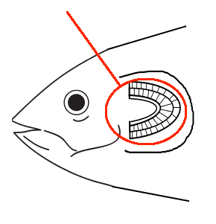

- Gill
- Operculum
- Gill Arch
- Gill Filament

- Identify the name of the structure indicated by the red line in the picture below.
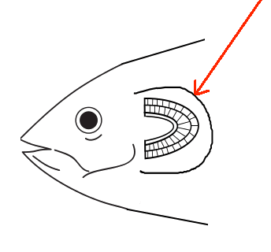
- Gill
- Operculum
- Gill Arch
- Gill Filament

- Identify the name of the structure indicated by the red line in the picture below.
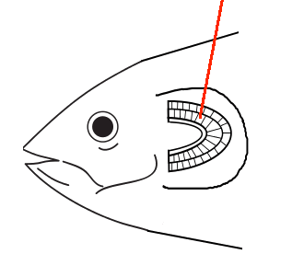
- Gill
- Operculum
- Gill Arch
- Gill Filament

- Identify the name of the structure indicated by the red line in the picture below.
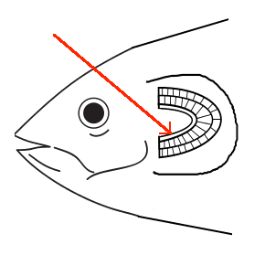
- Gill
- Operculum
- Gill Arch
- Gill Filament

- Identify the name of the structure that the green arrows are pointing to.
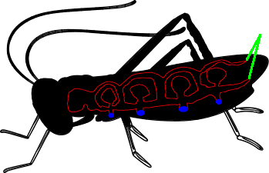

- Trachea
- Air Sacs
- Bronchi
- Spiracles

- Identify the name of the structure that the green arrows are pointing to.
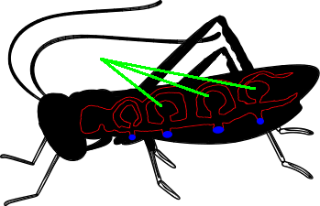
- Trachea
- Air Sacs
- Bronchi
- Spiracles

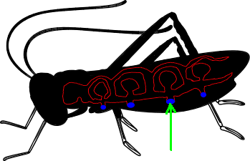
- Identify the name of the structure that the green arrows are pointing to.

- Trachea
- Air Sacs
- Bronchi
- Spiracles

